Test Case: tc002_SPX_Dev5_Crear_Requisicion_Spot_Tipo_Cobro_Project
Step 1 - Enter username and password and click to button Enter: Credentials Entered
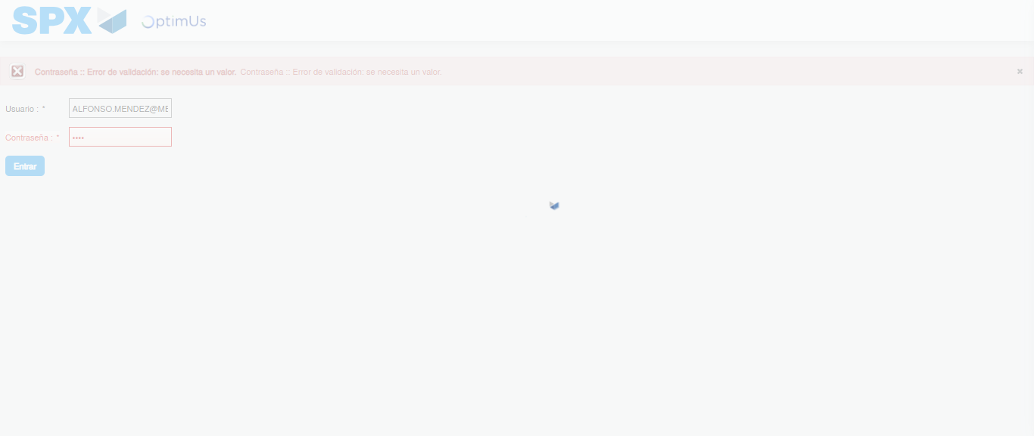Image file-name: QC_Testing-tc002_SPX_Dev5_Crear_Requisicion_Spot_Tipo_Cobro_Project-1783378623981

Step 2 - Select to UEN and Access to Spot Buy Requisitions : UEN Correctly selected and Correct access
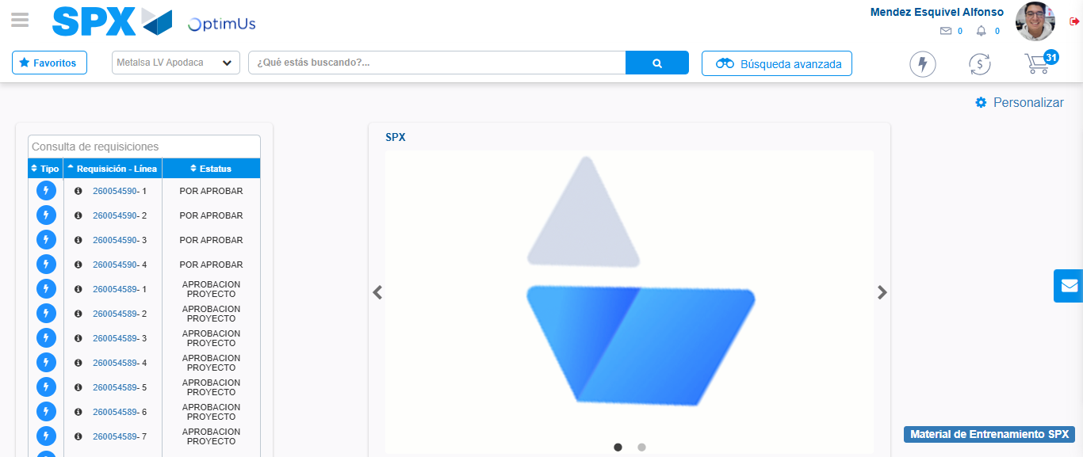Image file-name: QC_Testing-tc002_SPX_Dev5_Crear_Requisicion_Spot_Tipo_Cobro_Project-1783378648728

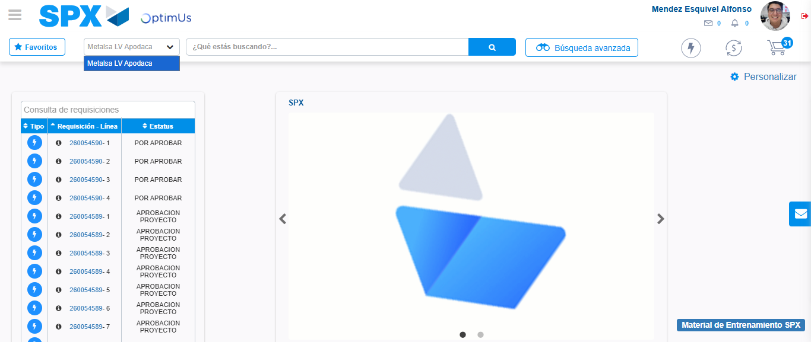Image file-name: QC_Testing-tc002_SPX_Dev5_Crear_Requisicion_Spot_Tipo_Cobro_Project-1783378651198

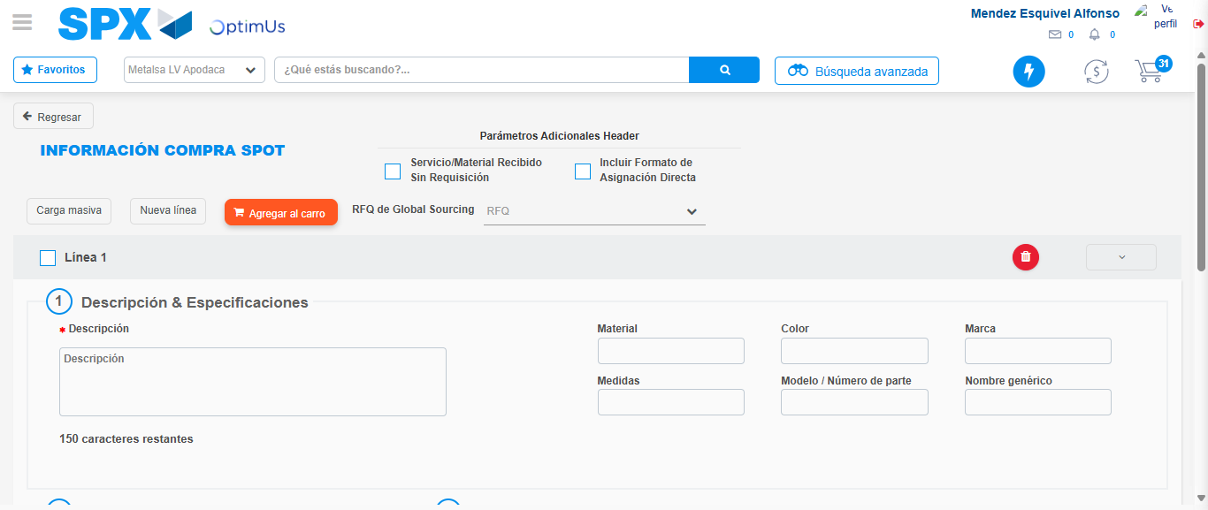Image file-name: QC_Testing-tc002_SPX_Dev5_Crear_Requisicion_Spot_Tipo_Cobro_Project-1783378670061

Step 3 - Data Capture Spot Buy Requisition: Data captured correctly
Image file-name: QC_Testing-tc002_SPX_Dev5_Crear_Requisicion_Spot_Tipo_Cobro_Project-1783378670252

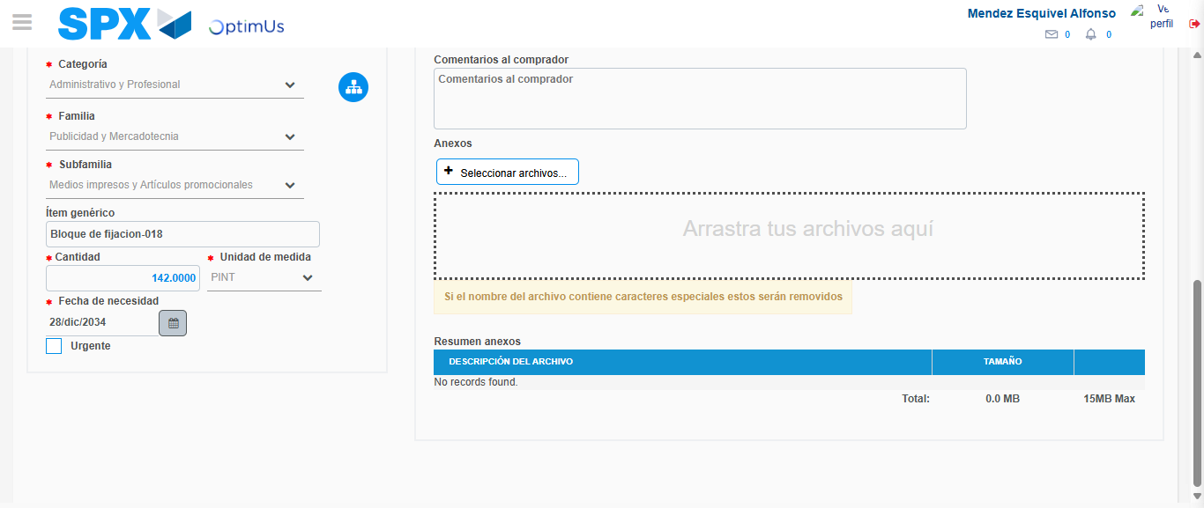Image file-name: QC_Testing-tc002_SPX_Dev5_Crear_Requisicion_Spot_Tipo_Cobro_Project-1783378680605

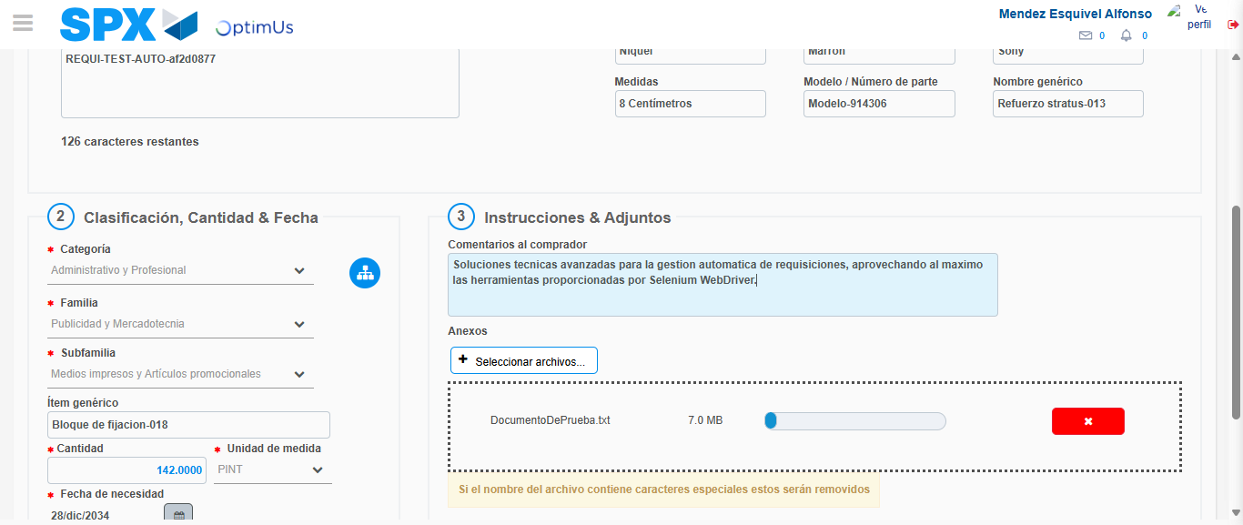Image file-name: QC_Testing-tc002_SPX_Dev5_Crear_Requisicion_Spot_Tipo_Cobro_Project-1783378681336

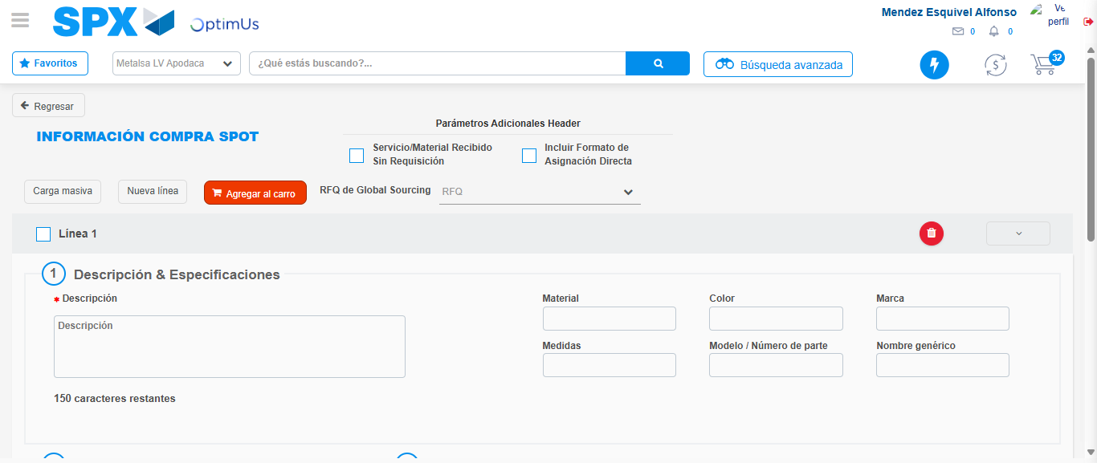Image file-name: QC_Testing-tc002_SPX_Dev5_Crear_Requisicion_Spot_Tipo_Cobro_Project-1783378688225

Step 7 - Return to Main Page SPX : Return to Main Page SPX
Image file-name: QC_Testing-tc002_SPX_Dev5_Crear_Requisicion_Spot_Tipo_Cobro_Project-1783378648728

Image file-name: QC_Testing-tc002_SPX_Dev5_Crear_Requisicion_Spot_Tipo_Cobro_Project-1783378651198

Image file-name: QC_Testing-tc002_SPX_Dev5_Crear_Requisicion_Spot_Tipo_Cobro_Project-1783378670061

Image file-name: QC_Testing-tc002_SPX_Dev5_Crear_Requisicion_Spot_Tipo_Cobro_Project-1783378690446

Image file-name: QC_Testing-tc002_SPX_Dev5_Crear_Requisicion_Spot_Tipo_Cobro_Project-1783378690604

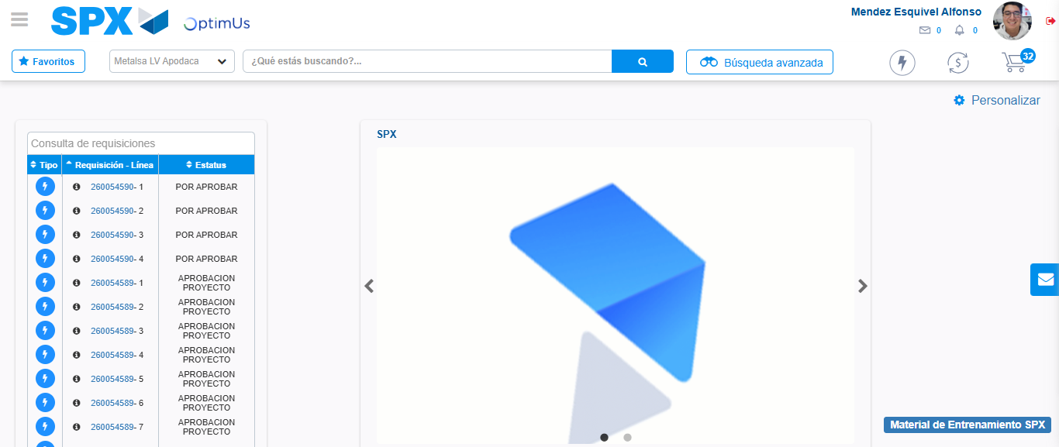Image file-name: QC_Testing-tc002_SPX_Dev5_Crear_Requisicion_Spot_Tipo_Cobro_Project-1783378711713

Step 8 - Log Out : Log Out SPX
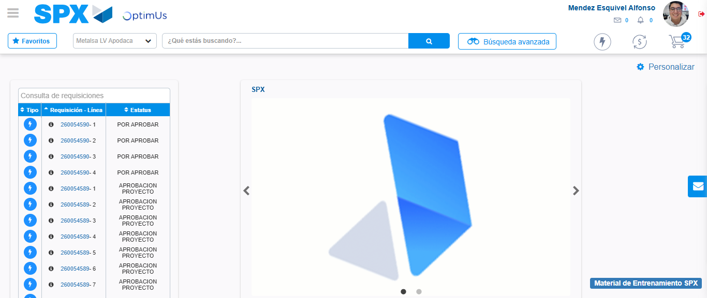Image file-name: QC_Testing-tc002_SPX_Dev5_Crear_Requisicion_Spot_Tipo_Cobro_Project-1783378711961

